SNOW SCAVENGER HUNT
Can you spot 6 of these winter things outside?
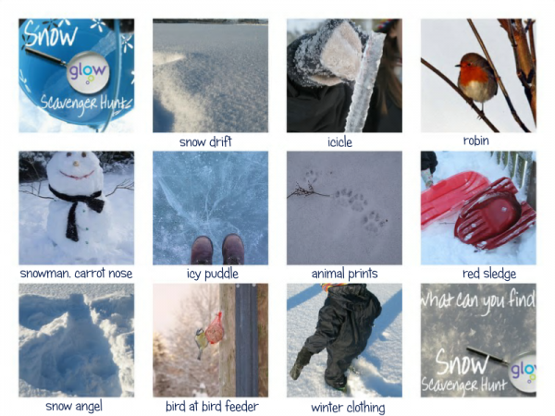
Photograph your findings then string your photos together using Photostory or Moviemaker using the instructions in Snow Central and upload into the Document Store.
You can add a commentary to your photos describing the things you have found and where you found them.

Remember to wrap up warmly when you go outside!

