June 21st 2012.
We had a marvellous visit to Drum Castle today.
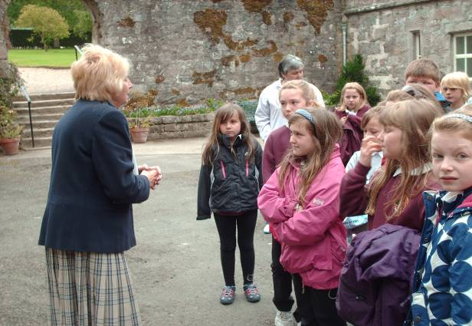
Our guide Anne giving us an introduction to Drum Castle.

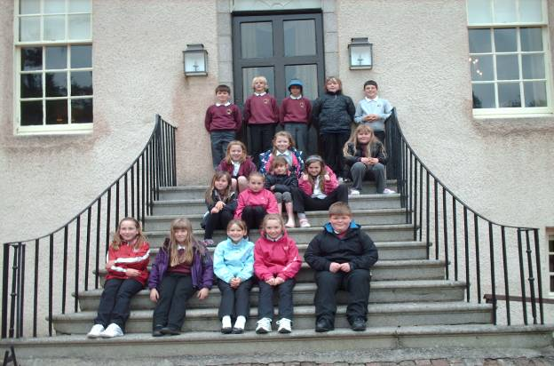

Sorry – no photos allowed inside the castle so we waited until we were out and about to go up the tower!
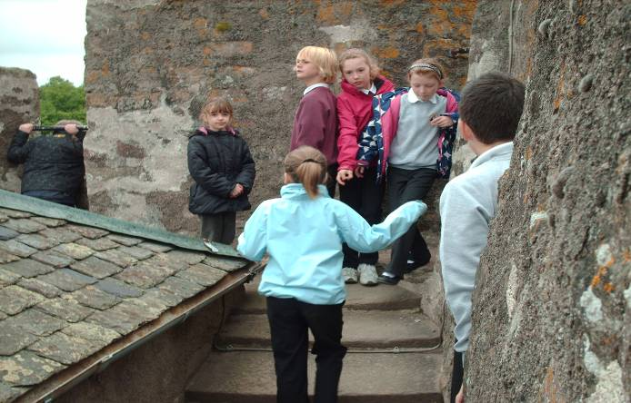
On the roof of the tower!

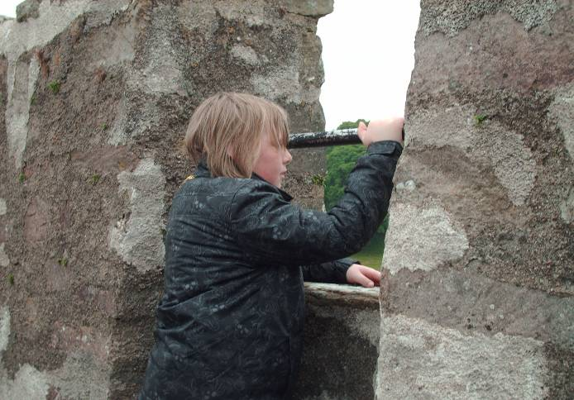

Chay enjoying the view!
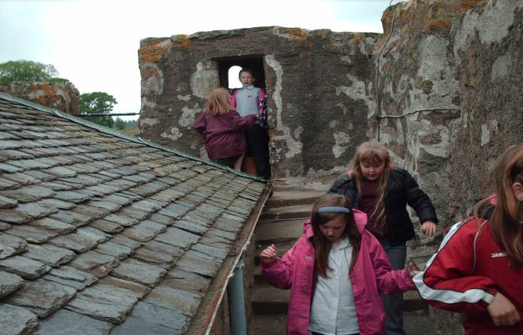

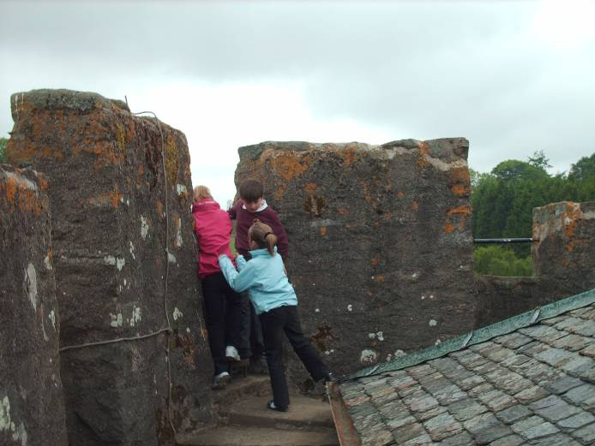

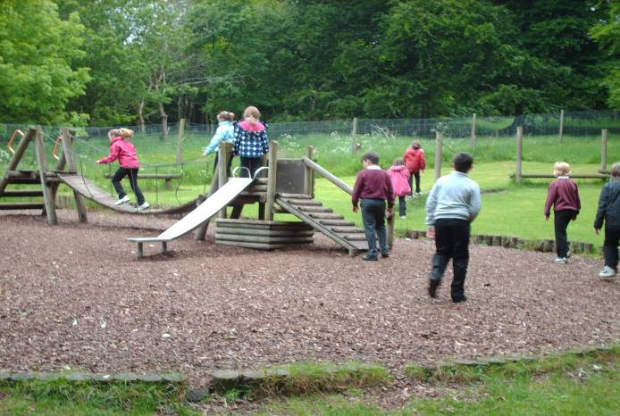

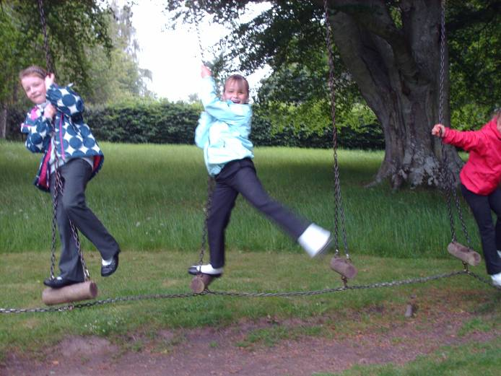
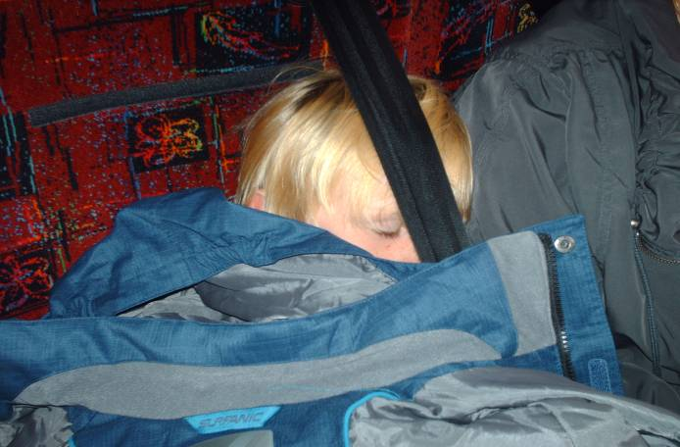

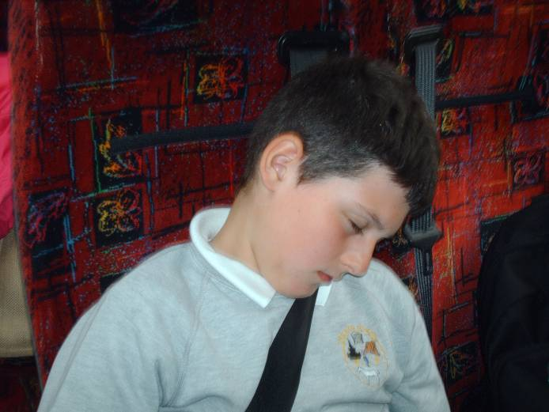

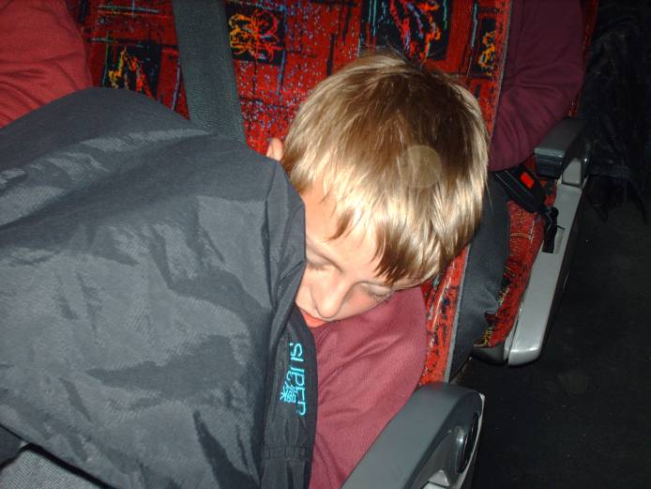

As you can see from the last 3 photos – exhausted after a lovely trip!!

Continue down for our Sailing day!!!!

Thanks to a grant from the Lottery Fund, we have been able to go for swimming lessons after school for 10 weeks and have a taster sailing day. Our confidence in the water is much better now!

Last Thursday we had the opportunity to go sailing at Peterhead Marina.

Ready to go!!

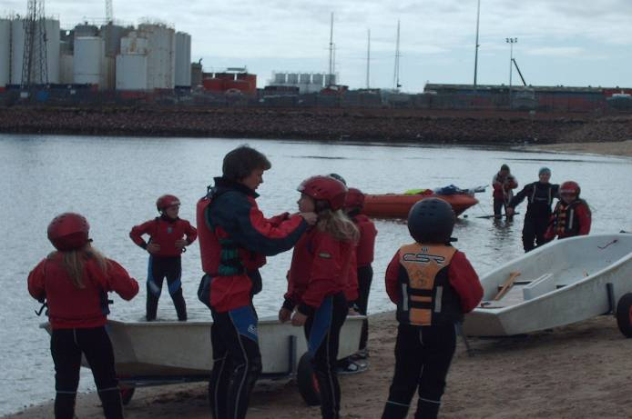
Sorting Lia’s chin strap.
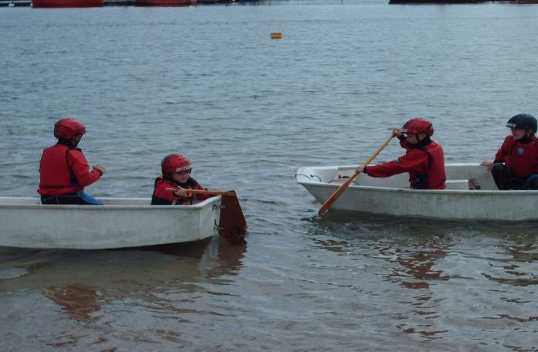
Learning how to paddle and steer.
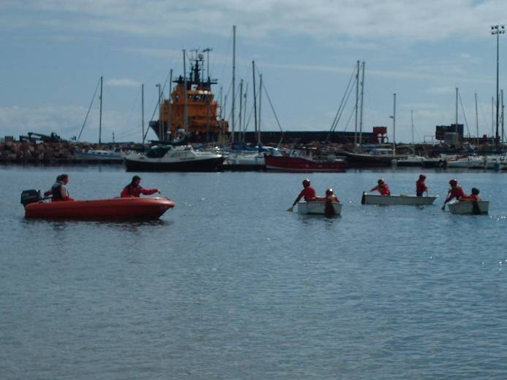
Out in the Marina!
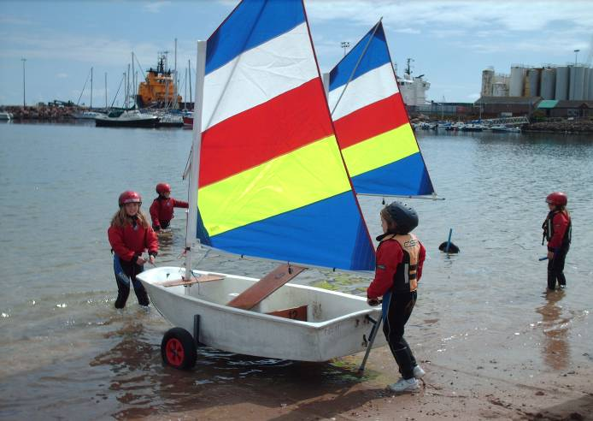
Our boat is ready! We’ve got sails now!
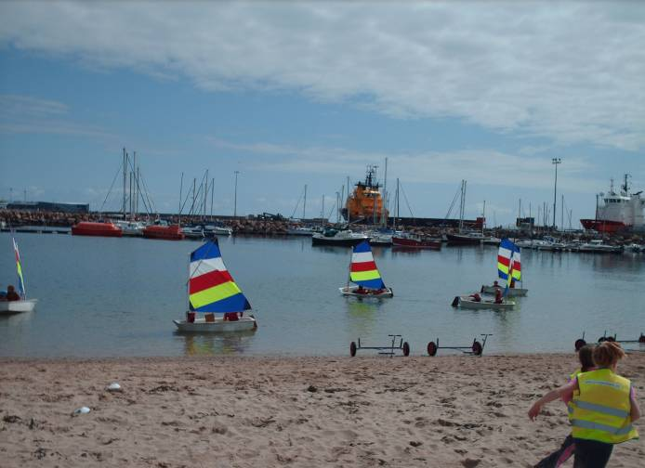
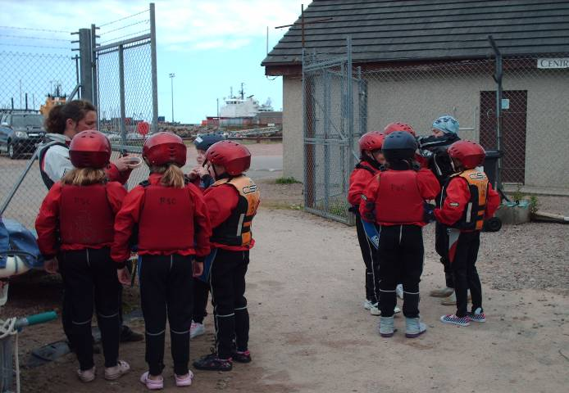

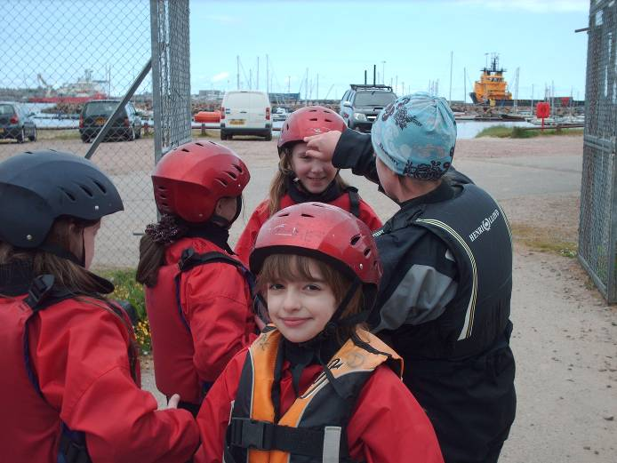
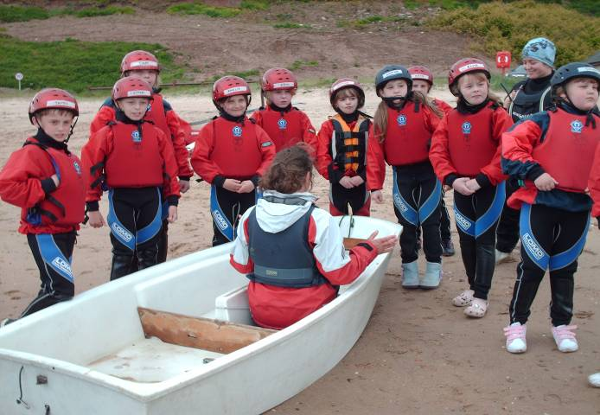

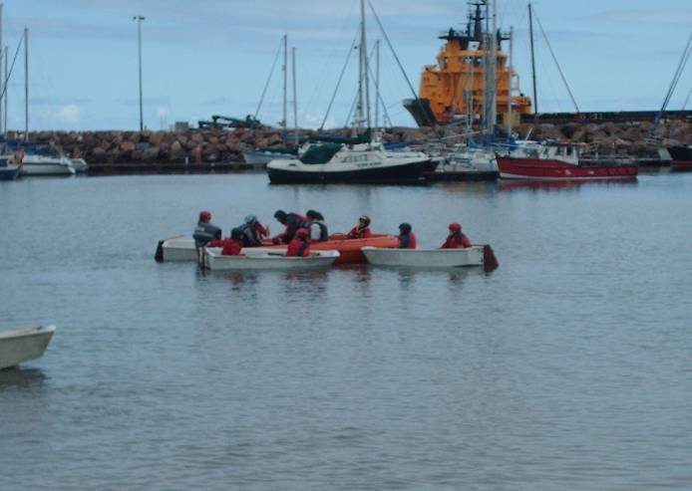
Getting ready for our treasure hunt game.
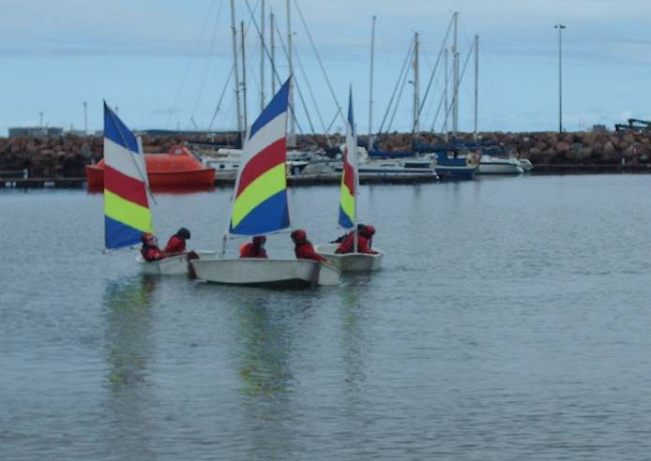

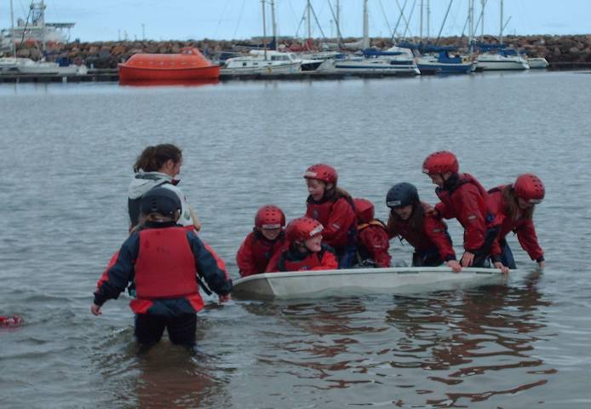
How many children does it take to sink the boat?
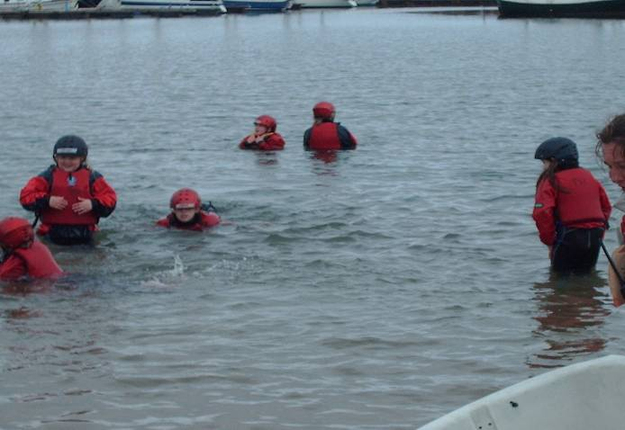
Getting wet!!
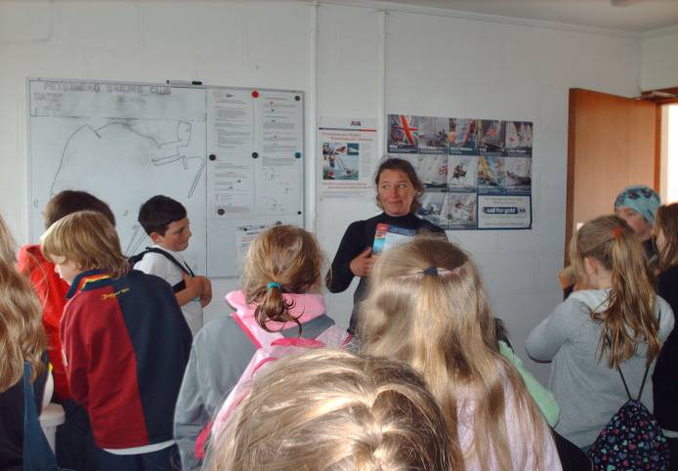
Certificate time!! Thank you Angie for a brilliant day.

