

and

Rainforests

Primary 6

This term we have been finding out about Deserts and Rainforests.
We made models of these different habitats.

Group 1 --- Angus, Rhia + Jordan

We made a model of a desert habitat

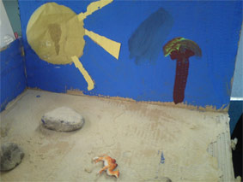
Materials used: Sand, stones, paint, cardboard

In our group we think we did well
at painting because it was the only
thing we did together.

We think the painting we did on our model stands out so it was the best part of our model.
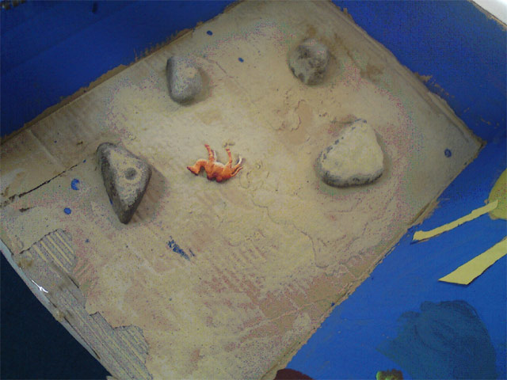

We most enjoyed using
real life stuff and art materials to make our model.

Next time we think we could do better at the sand for our dunes. We had a lack of sand.
Group 2 - Our rain forest model

Group members: Katie, Glen, Amy and Ryan

We made a model of a rainforest habitat. It had tall trees, lots of animals and some tribe people.

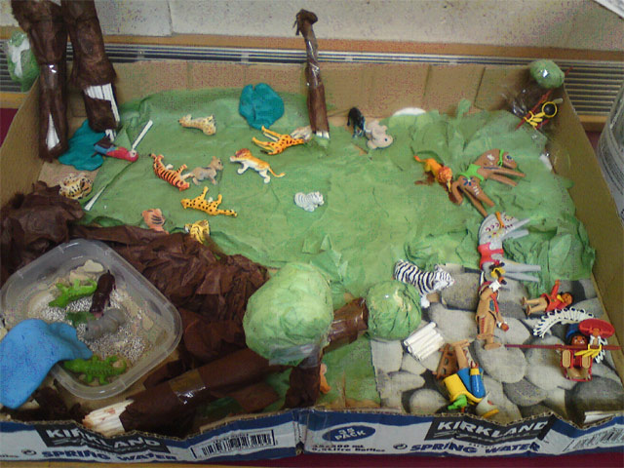
We used long sticks, toy
animals and thin paper the grass and mud to mak our model. We included animals in our model suchas: tigers, leopards, elephants, monkey, zebras,
hippos and crocodiles

In our group we think we did well at placing the animals correctly.
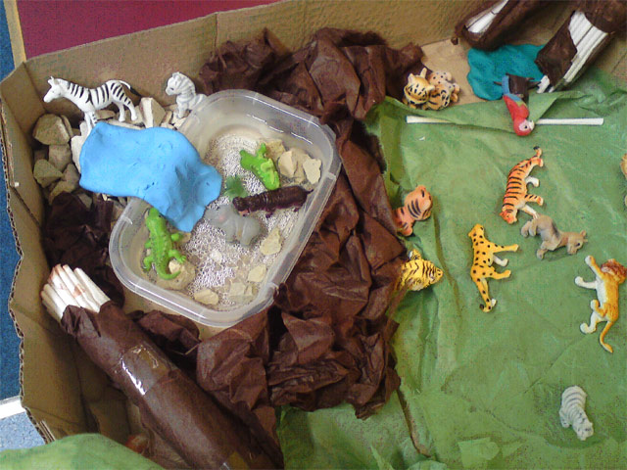
We think the best bit about our model is the waterfall we made.

Next time we think we could add more trees. This would make it look more like a rainforest. It is too bare and looks more like a park just now.

Our favourite part was working with plasticine.
Group 3
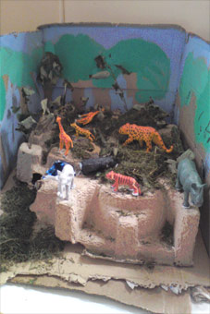
We made a habitat model
of a rainforest with a waterfall
near it and animals are around it.

We used cut grass, blue see through paper, animals (brought in from home) stones, card and glitter.

We think we did well at working together as a group to complete our task.

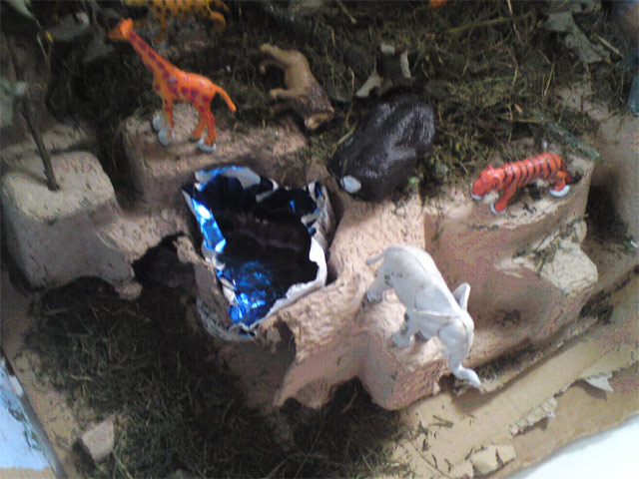
We think using real water for our waterfall made our model look really good.
We really enjoyed using real stuff like grass to make our models.

Next time we could do better by testing it out before doing.

In our group we each had a different role.

Cameron, Lauren, Gillian

Group 4
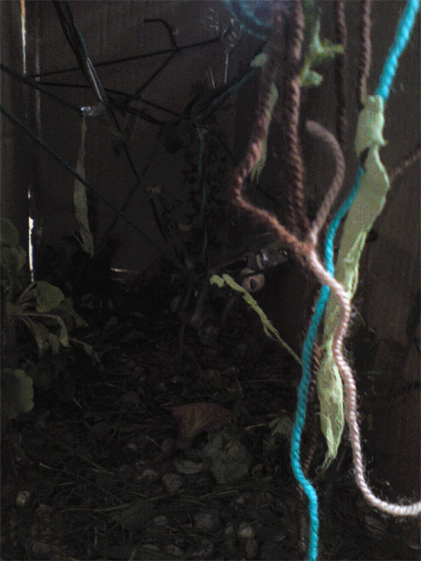
Our model was of a dark and spooky Jungle.

We used grass,
toy models of animals,
twigs, leaves, wool for vines,
branches from berry trees and card.

We think we did well at working together.

We thought our vines looked the best on our model. They made it quite spooky.
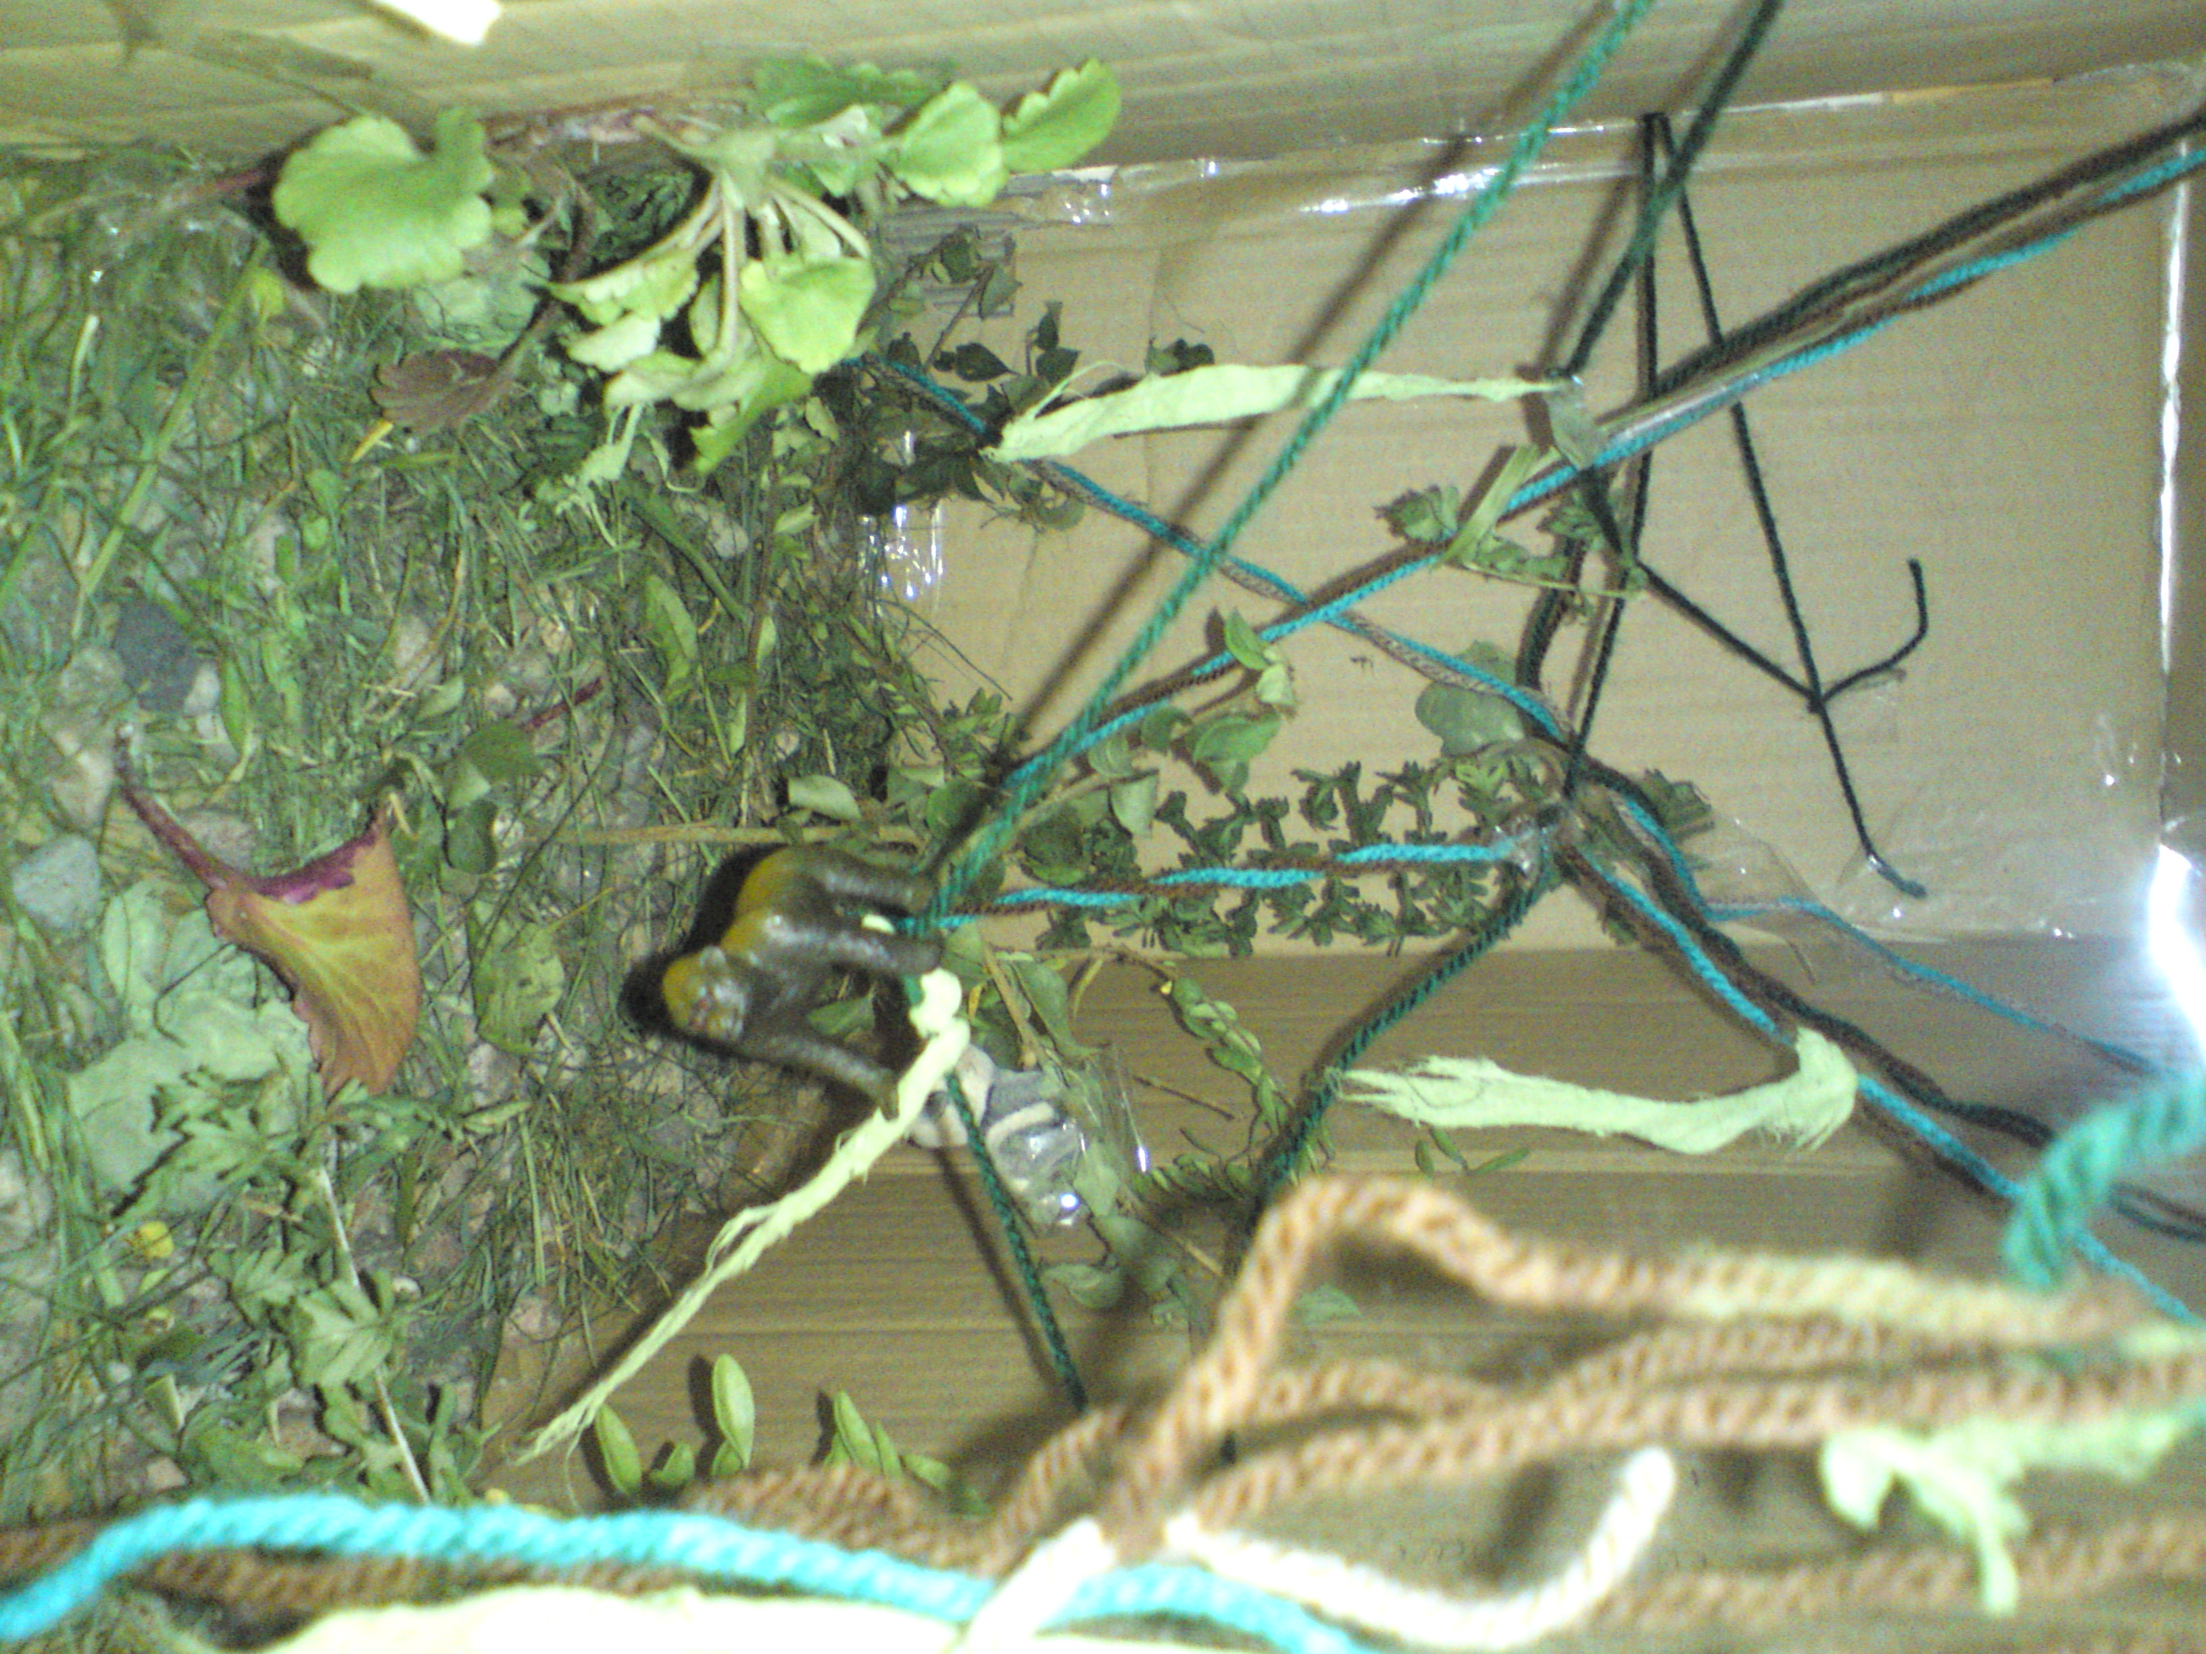
Next time we could do
better at trying to be
fair to each other and
not be bossy to anyone.

Caitlin, Jack, Georgia, Steven

Group 5

Our model is a habitat of the rainforest floor.

Group Members: Dylan, Daniel, Kelsie

We included some special features: waterfalls, grass, stones, animals, trees
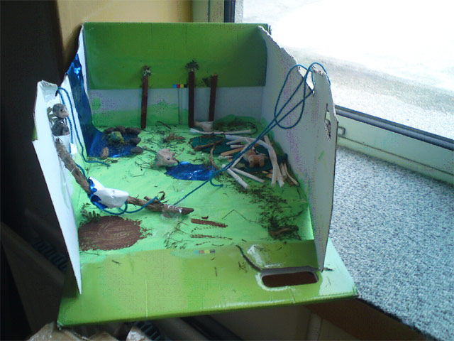
In our group we had roles such as: The Boss, Timekeeper and Progress Professor

We did well at using real life materials to make our model look more real.

Next time we could have done better at adding more detail and features to our model.

