Newsletter: October 2013
The holidays start at the end of the week and it is hard to believe that a whole term has gone by already. The term has been a very busy one and our new pupils and staff have settled very well into life at Strichen School.

The blog site will have a variety of new posts up before the end of the week and photos of some of the many things that have been happening recently. The blog continues to be very popular and to date we have had over 23 thousand hits on it.

Donation to School:
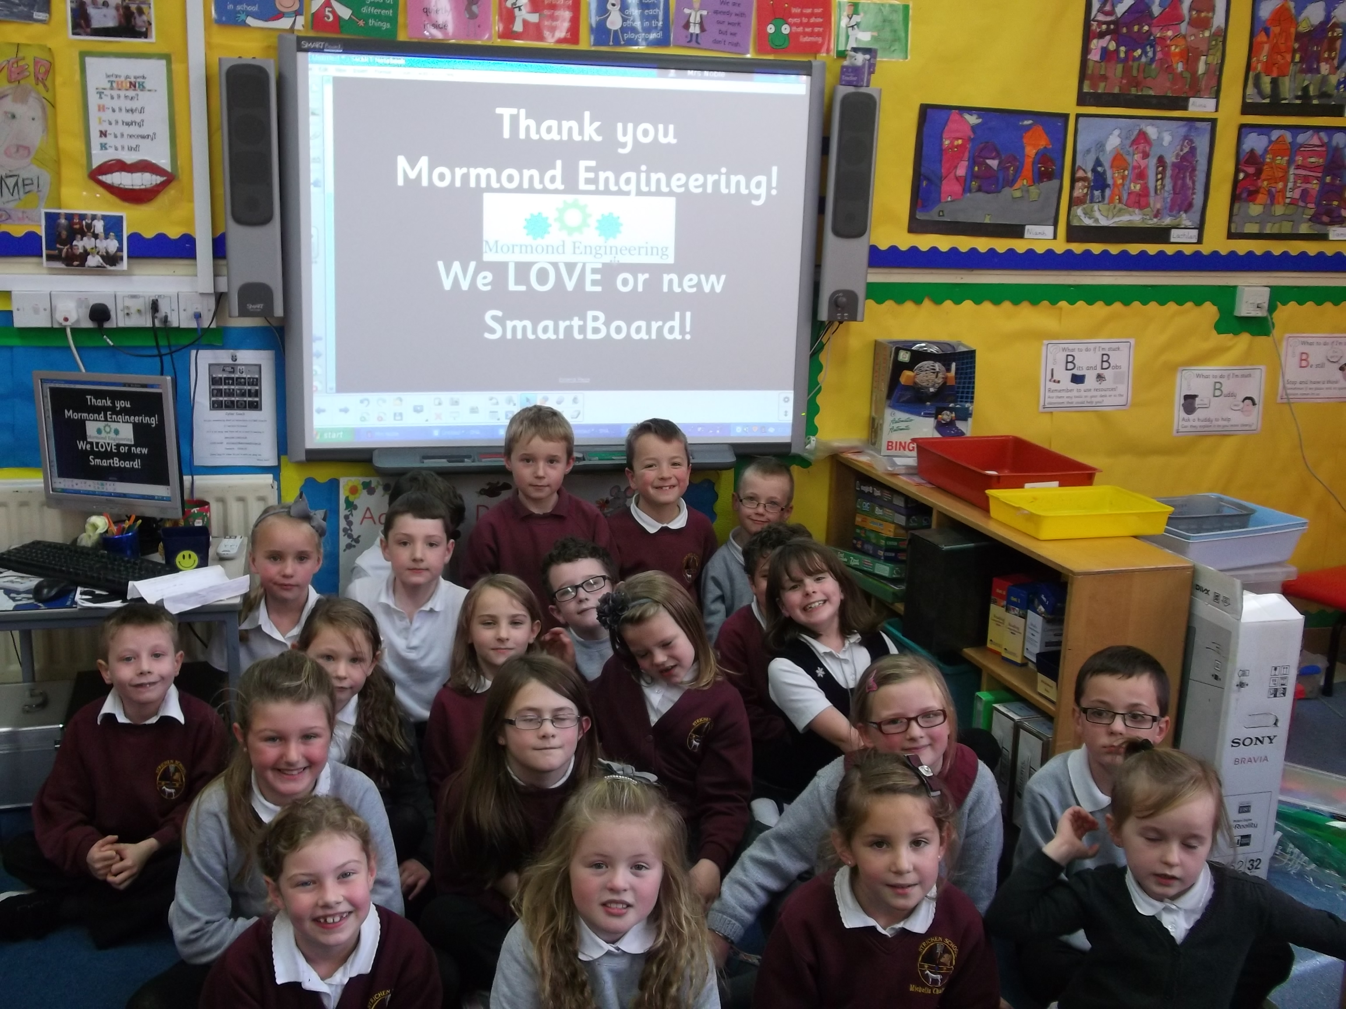
We were delighted to receive a very generous donation to school funds from Mormond Engineering just before the summer. The money was donated to school to allow us to purchase two new interactive whiteboards that required replacing in Mrs Noble’s and Miss Clark’s classes. We were also able to purchase a new projector to replace the one in Mrs Veitch’s class that was nearing the end of its life.
This was a significant donation and we would like to thank Mormond Engineering for this very generous gift. It has helped us replace some very expensive pieces of equipment which we would have struggled to replace without some significant fund raising by the SSA. On behalf of all the pupils at the school we would like to thank them for their support which will help three of the classes carry out their learning effectively in class.

Macmillan Charity Fundraiser:
Three classes recently organised and ran another very successful charity event under the guidance of Mrs Veitch, Miss Clark and Miss Cruden. Pupils from Pr 4/5, Pr 5/6 & Pr 7 planned the event and so far have managed to raise over £900. We would like to thank everyone who helped with the preparations and everyone who came along and supported the event so generously. This is the fifth year this event has been held and to date the pupils and families have raised over £4000 for the Macmillan Cancer Charity. This is a great record and everyone should be proud of their efforts.

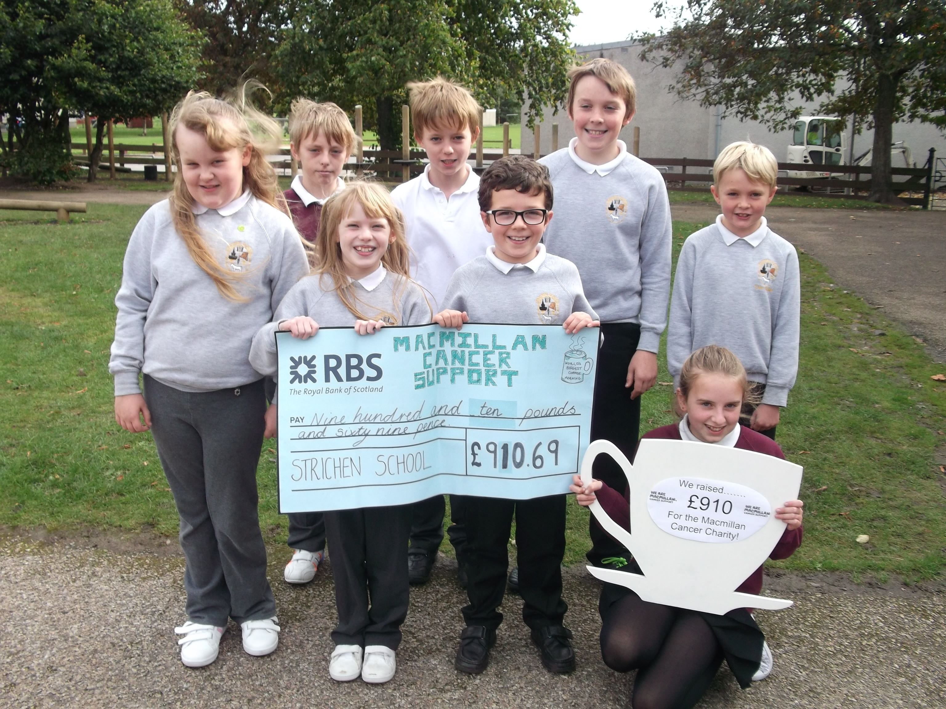

SSA AGM
The SSA held their AGM recently in the school but the turn out was limited. Reports were made by the chairperson, the treasurer and Mr Jenkins.
We were also delighted to welcome PC John Pirie to the event who gave a talk about internet safety for parents. He covered many different issues and

highlighted some of the issues parents should be aware of with regard to ensuring your children access and use the internet safely. We would like to thank PC Pirie for giving up his time and giving such an interesting and thought provoking presentation.

New Pitsligo Art Exhibition
The annual art exhibition in New Pitsligo was held recently and Strichen School had a large entry of exhibits once again. The work entered was of a high standard and was a mix of work from last session and from this session. A number of pupils were prize winners and received small monetary prizes. Well done to everyone who had a piece of work exhibited!

The prize winners from the school were:
Kaitlyn Keith, Louise Downie, Anya Fisher,
Callum Gordon, Niamh Allan, Michella Chalmers, Anona Arnott, Eilidh Craib,
Madison Elmslie, Harris Craig, Robert Gray and Teigan Allan.

Open Afternoon
A large turnout of parents and relatives attended our recent open Afternoon on Monday. Each class was very busy all afternoon as people looked at their children’s work and at the displays round the school. We received many positive comments from visitors and we are delighted that this event is so well supported. The children especially enjoy it and like to have the opportunity to share their learning with you.

Assemblies
Over the term we have had a variety of assemblies which give us the opportunity to share a wide variety of activities with the
whole school. We appreciate the input by visitors who take assemblies and the class assemblies are another great way of sharing their learning with the whole school.

Assemblies this term:
- Crossing Bridges Mr Jenkins
- The Lord’s prayer Rev Fothergill
- The Lost Sheep Jamesie
- Our Buddies Primary 7
- Children in Syria Primary 5/6
- The Walls of Jericho Jamesie
- World Smile Day Whole School
- Safety PC Pirie

Influenza Vaccinations P6 & P7
If any parent of pupils in P6 or P7 has not returned the envelope about the flu vaccinations could they please do so as soon as possible? If there is no reply your child will not get their vaccination.

Dates for the Diary

Fri 11th Oct: Last Day of the term

Mon 28th Oct: Term 2 begins

Mon 4th Nov: Influenza
vaccinations P6 & 7

Wed 6th Nov: Book Fair Preview Day

Thurs 7th Nov: Book Fair Day

Mon 11th Nov: In-Service Day
(Pupils off)

Tues 12th Nov: In-Service Day
(Pupils off)

Thurs 12th Dec: Christmas Lunch &
SSA Christmas Fair

Thur 19th Dec: Last day of the term

Mon 6th Jan: Term 3 begins

We hope everyone has a great holiday.

Mr Jenkins
Head Teacher

