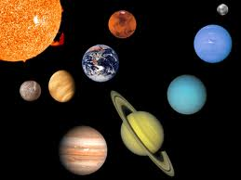
Many layers three to be exact but there is only one tiny Mars.
As rocky as a cobbled road.
Red Mars is actually orange not as red as you think.
Venus is close to Mars but not right next to it
Evil heat as hot as a fire sizzling in a chimney.
Lovely Mars has two moons.
Little Mars is next to huge Jupiter and medium Earth.
Orange popping lava oozing out of holes.
Uneven moving marvellous Mars.
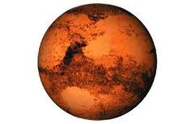
Solid, spinning & small Mars.
Katie

